Multimodal Depression Detection Using Speech and Linguistic Behaviour Analysis Across Conversational Phases
Debi Prasad Nanda¹, Chandna Nayak², Prabyasachi Mohanty³, Debasish Nanda⁴, Pushpaja Priyadarshini⁵,
Ms. Ruby⁶
Department of Computer Science and Engineering,
Siksha ‘O’ Anusandhan (Deemed to be) University,
Bhubaneswar, Odisha, India
debiprasad1722@gmail.com, chandnanayak9@gmail.com, prabyasachi2004mohanty@gmail.com, debasishnanda467@gmail.com, pushpajapriyadarshini@gmail.com, ruby@soa.ac.in

Abstract. Depression is a prevalent mental health condition that adversely impacts an individual’s communication and behaviour. Diagnosis of depression relies on the self-reporting and assessment of mental health professionals, both of which are resource-intensive processes. To automate the diagnosis of depression, a preprocessing-focused multimodal machine learning (ML) system is proposed using the DAIC-WOZ clinical interview dataset. Two modality-specific data preprocessing steps are carried out on the dataset. For the audio modality, a pre-emphasis filter, bandpass filter, and amplitude normalisation are applied. For the text modality, annotations, filler words, and text pertaining to individuals other than the participants are removed. Each interview is divided into three phases containing three consecutive interview phases. From the audio recordings, 132 audio features are extracted, including Mel-Frequency Cepstral Coefficients (MFCCs) of order 13 with delta coefficients, spectral features, pitch features, jitter, shimmer, Harmonics-to-Noise Ratio, and pause features. For the textual modality, 768-dimensional Sentence-BERT text embeddings and seven text features are extracted. Six ML classifiers are trained and tested on the dataset using single-split and 10-fold cross-validation for each phase. The results of the study indicate that the multimodal approach yields higher accuracy and F1-score values than either the audio or text modality alone. The best performance is achieved by the Random Forest classifier with an accuracy of 83.6% and F1-score of 0.71 on the single-split cross-validation method for Phase 1. The text and audio features exhibit the most discriminative values for the early phases of the interviews. The results of this study indicate that audio and text modality features preprocessed through the techniques described can be accurately classified using traditional ML methods for the automated diagnosis of depression.
Keywords: Depression Detection, Multimodal Analysis, Acoustic Feature Extraction, SBERT Embeddings, Phasewise Segmentation, DAIC-WOZ, Machine Learning, Speech Processing.

1. Introduction

Across the entire earth, the World Health Organization reports that depression impacts more than 280 million people because this health condition is a very common and heavy mental illness. Verbal communication and the way a human speaks are heavily changed by depression when a person feels constant sorrow or loses their interest in life. Experts claim that many individuals suffering from this sickness do not receive a formal medical name for their struggle because tools like the PHQ-8 and PHQ-9 questionnaires depend too much on the personal opinion of the medical professional. New computer methods which study the patterns of speaking offer a hopeful way forward even though checking mental health was previously hard to provide for all people.

1.1 Motivations

Depression screening usually depends on patients filling out questionnaires and talking to doctors. The problem is that patients might not always tell the truth and doctors can interpret things differently. When people talk there are things like the way they say things how long they pause, how fast they talk and what they actually say that can show if they are depressed. We have found that these things are indicators of depression. We also have access to recordings of doctors talking to patients like the DAIC-WOZ recordings, which can help us study these signs.

There is a lot of potential, for research here. We can make a system that looks at both how people sound and what they say and make sure we prepare the data carefully so we get information from it. This system can help us understand depression better by looking at the Depression screening and the signs of depression.

1.2 Objectives
The primary objectives of this research are: (i) to implement a preprocessing pipeline that isolates participant speech from clinical interview recordings and cleans associated transcripts; (ii) to extract a comprehensive set of acoustic and linguistic features from phase-segmented interview data; (iii) to evaluate and compare the performance of multiple machine learning classifiers under unimodal and multimodal configurations; and (iv) to analyse the temporal distribution of depression cues across conversational phases.

1.3 Original Contributions
The principal contributions of this work are as follows:
- A structured two-stage preprocessing pipeline that eliminates interviewer speech using ground-truth timestamps, applies spectral filtering, and standardises textual transcripts for NLP-based analysis.
- A phase-wise temporal segmentation approach that divides clinical interviews into three equal conversational phases, enabling the modelling of depression evolution across interview stages.
- Integration of 132 acoustic features (including MFCCs with deltas, spectral features, jitter, shimmer, HNR, and pause statistics) with 777 text features (Sentence-BERT embeddings and linguistic markers) to form a 909-dimensional multimodal feature space.
- A systematic comparative evaluation of six machine learning classifiers under 10-fold stratified cross-validation, identifying CatBoost and Random Forest as the most effective models for depression detection from both unimodal and multimodal feature sets.

1.4 Paper Layout
The remainder of this paper is organised as follows. Section 2 reviews related work on speech-based and multimodal depression detection. Section 3 describes the proposed system, dataset, and methodologies. Section 4 presents experimental results and evaluation. Section 5 provides a comparative performance analysis. Section 6 discusses contributions, and Section 7 concludes the paper with future directions.

2. Literature Survey
Research in automated depression detection has evolved substantially over the past decade, progressing from single-modality acoustic systems to sophisticated multimodal architectures. Early work by Valstar et al. [1] employed low-level descriptor acoustic features with support vector machines on the AVEC challenge dataset, establishing baseline benchmarks for regression-based depression scoring. Subsequent studies shifted toward deep learning: Cummins et al. [2] applied Long Short-Term Memory networks on MFCC sequences from DAIC-WOZ recordings, demonstrating the utility of recurrent architectures for capturing temporal speech dynamics but without integrating linguistic content.
Convolutional approaches gained traction with Ma et al. [3], who trained CNNs directly on audio spectrograms. While these models achieved competitive results, they discarded potentially informative linguistic signals. Gong and Poellabauer [4] proposed an early fusion of ResNet audio features and text embeddings, though their system lacked conversational phase modelling. On the text side, Niu et al. [5] leveraged BERT representations for transcript-based depression detection, achieving strong F1 scores but neglecting acoustic cues entirely.
Transformer-based multimodal architectures were explored by Yang et al. [6] using gated recurrent units with attention mechanisms. While these approaches achieved high accuracy, their computational cost and lack of interpretability limited practical applicability. Othmani et al. [7] combined ResNet audio processing with NLP features but did not examine temporal conversational dynamics. Rejaibi et al. and Ray et al. explored LSTM and handcrafted feature approaches respectively, both confirming the value of acoustic signals while acknowledging the absence of phase-level temporal analysis as a key limitation.
A consistent research gap across prior systems is the absence of phase-wise conversational analysis. Depression does not manifest uniformly across an interview; its indicators may be more pronounced in early self-referential responses or in later, more emotionally loaded segments. The present work addresses this gap through structured conversational phase segmentation, comprehensive preprocessing-first pipeline design, and systematic multimodal feature integration evaluated across multiple classifiers.

Table 1. Literature survey summary of existing depression detection systems.
S. No. | Author & Year | Methods/Techniques Used | Dataset Used | Research Outcomes | Findings
1 | Guo et al. (2022) | Feature Extraction: Transformer-based (RoBERTa, wav2vec 2.0) with Topic AttentionClassification: Two-branch multimodal transformer with late fusion | DAIC-WOZ dataset | Accuracy: 90%+ (reported improvement)  Recall: Improved via attention | Effective use of topic-level attention improves detection; handles data scarcity using pre-trained models but still limited by small dataset size
2 | Gan et al. (2025) | Feature Extraction: LLM (LLaMA), Audio processingClassification: Teacher–Student multimodal fusion with attention | DAIC-WOZ dataset | F1 Score: 0.991 | Very high accuracy using teacher-student architecture; strong multimodal fusion but computationally complex and data-dependent
3 | Gong & Poellabauer (2017) | Feature Extraction: Topic Modeling (context-aware segmentation)Classification: Multimodal feature vector + feature selection | DAIC-WOZ dataset | Improved performance over baseline methods | Captures temporal/contextual details effectively; limited by small sample size and feature dimensionality issues
4 | Nykoniuk et al. (2025) | Feature Extraction: CNN + Bi-LSTM + Self-AttentionClassification: Early and Late Fusion models | DAIC-WOZ, EDAIC-WOZ datasets | Accuracy: 86%  F1 Score: 0.79 | Early fusion performs better; multimodal improves accuracy but dataset imbalance affects reliability
5 | Yoo & Oh (2023) | Feature Extraction: CNN (audio), Transformer (text)Classification: Tensor Fusion Network + LSTM | DAIC-WOZ dataset | Moderate improvement (no exact metrics provided) | Fusion of text and voice improves detection; lacks detailed quantitative evaluation and scalability analysis
6 | Xu et al. (2025) | Feature Extraction: BERT (text), wav2vec 2.0 (audio)Classification: Bi-LSTM + multi-scale convolution + adaptive pooling | CMDC & DAIC-WOZ datasets | F1 Score: Improved significantly  RMSE reduced | Strong cross-modal feature integration; handles multiple datasets but requires large training data and complex architecture
7 | Park & Moon (2022) | Feature Extraction: BERT-CNN (text), CNN-BiLSTM (audio)Classification: Attention-based multimodal fusion | DAIC-WOZ dataset | Improved accuracy over single-modal models | Attention-based fusion improves accuracy; still dependent on quality of preprocessing and multimodal alignment

3. Proposed System / Model

3.1 Dataset Description
This study utilises the DAIC-WOZ (Distress Analysis Interview Corpus – Wizard-of-Oz) dataset, a widely employed benchmark corpus for computational depression detection research . The dataset contains semi-structured clinical interviews conducted by a virtual agent named Ellie, designed to elicit naturalistic responses from participants regarding their emotional state, daily activities, and personal experiences. Each session includes a synchronised audio recording and a time-stamped transcript in CSV format, with speaker labels differentiating participant utterances from interviewer turns.
After label filtering against the provided PHQ-8 binary ground-truth file, 141 unique participants were retained. Each participant contributed data across three conversational phases, yielding 423 participant-phase records. The binary label (PHQ-8 Binary) classifies participants as non-depressed (0) or depressed (1). The dataset exhibits a class imbalance with approximately 70.2% non-depressed and 29.8% depressed samples. Table 2 summarises the dataset characteristics.

Table 2. Dataset characteristics of the DAIC-WOZ corpus used in this study.
Attribute | Details
Dataset Name | DAIC-WOZ (Distress Analysis Interview Corpus – Wizard-of-Oz)
Total Participants | 142 (after label filtering from 188 audio files)
Interview Format | Semi-structured clinical interview with virtual interviewer (Ellie)
Audio Format | WAV, 16 kHz mono, participant-only segments extracted
Label Type | Binary (PHQ-8 Binary: 0 = Non-depressed, 1 = Depressed)
Class Distribution | Non-depressed: 297 samples (70.2%), Depressed: 126 samples (29.8%) across 3 phases
Phases | Phase 1 (early interview), Phase 2 (mid interview), Phase 3 (late interview) — equal-thirds split
Transcript Format | CSV with columns: speaker, value, start_time, stop_time
Modalities | Audio (acoustic features) + Text (linguistic features from transcripts)
Feature Dimensionality | Audio: 132 features; Text: 777 features (incl. SBERT); Multimodal: 909 features

3.2 Schematic Layout of the Proposed System
The proposed framework processes audio and transcript modalities through parallel preprocessing pipelines before phase-wise feature extraction and classification. Figure 1 illustrates the overall system workflow.
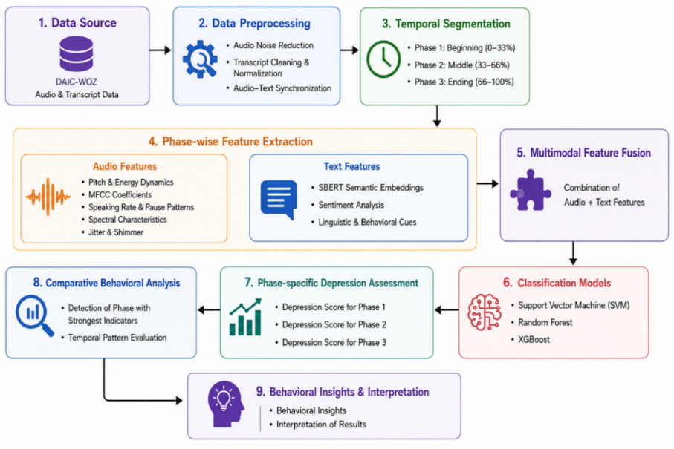
Fig. 1. Overall workflow of the proposed multimodal depression detection framework: from raw interview data through preprocessing, phase segmentation, feature extraction, fusion, and classification.

3.3 Methodologies Used
3.3.1 Audio Preprocessing.
The audio preprocessing pipeline operates on raw DAIC-WOZ WAV files and comprises five sequential stages. In the first stage, the system reads the associated transcript CSV to identify participant speech boundaries. Using ground-truth timestamps (start_time, stop_time), only segments attributed to the participant are extracted. This eliminates the virtual interviewer’s voice without requiring speaker diarisation, ensuring that all subsequently extracted acoustic features represent exclusively the participant’s behavioural speech patterns.
Extracted participant segments are concatenated into a single continuous audio signal to reconstruct the complete speech timeline. Multi-channel recordings are converted to mono to prevent channel imbalance artefacts. The audio is resampled to 16,000 Hz. A pre-emphasis filter (α = 0.97) is then applied to amplify high-frequency components that carry critical prosodic information. Finally, a fifth-order Butterworth bandpass filter with passband 100–7500 Hz removes low-frequency rumble and high-frequency noise, and the signal is amplitude-normalised to the range [−1, 1]. Figure 2 presents the audio preprocessing pipeline.
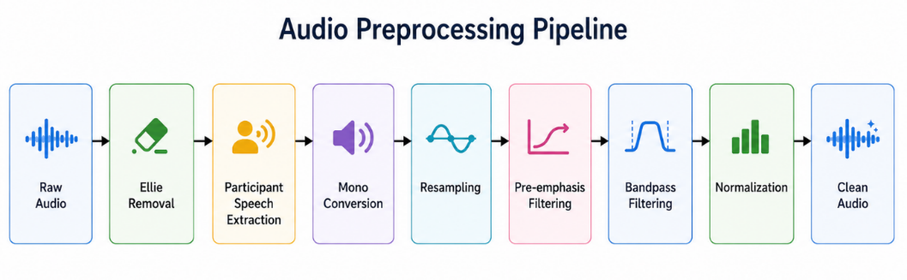
Fig. 2. Audio preprocessing pipeline: participant segment extraction, concatenation, mono conversion, pre-emphasis filtering, bandpass filtering, and normalisation.

3.3.2 Transcript Preprocessing.
Raw transcript files contain annotation artefacts including XML-style tags (e.g., <laugh>, <noise>), square-bracket markers, filler words, and interviewer speech. The preprocessing pipeline applies a sequence of operations: (i) annotation tag removal using regular expressions; (ii) extraction of meaningful content from parenthetical expressions; (iii) removal of filler-only utterances (‘uh’, ‘um’, ‘mm’, ‘hmm’, etc.); (iv) retention of only participant-labelled rows; and (v) whitespace normalisation. The resulting cleaned transcripts provide high-quality participant speech data for linguistic feature extraction. Figure 3 illustrates the transcript preprocessing workflow.
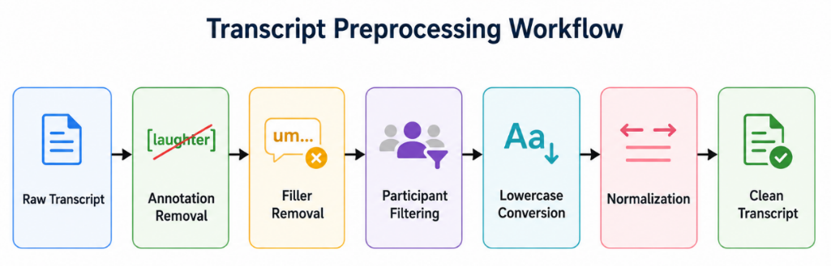
Fig. 3. Transcript preprocessing workflow: raw transcript ingestion, annotation removal, filler elimination, participant filtering, and output of cleaned CSV files.

3.3.3 Phase-wise Conversational Segmentation.
A key contribution of this study is the temporal segmentation of clinical interviews into three equal conversational phases. Each cleaned transcript is partitioned into Phase 1 (early interview), Phase 2 (mid interview), and Phase 3 (late interview) based on the sequential ordering of participant utterances. Corresponding audio segments are extracted by mapping the phase-assigned transcript timestamps back to the audio signal. This produces three distinct feature vectors per participant, allowing classifiers to operate on temporally localised behavioural representations rather than global interview statistics. Figure 4 depicts the phase segmentation scheme.
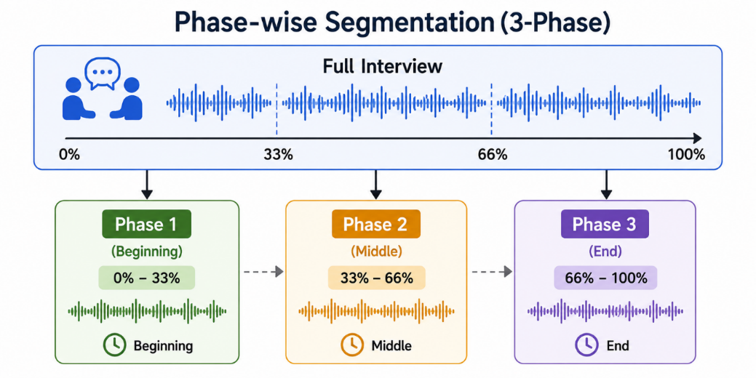

Fig. 4. Phase-wise conversational segmentation: each interview is divided into three equal phases based on transcript utterance ordering, with corresponding audio segments extracted using timestamp alignment.

3.3.4 Feature Extraction.
Feature extraction is performed independently for each participant-phase pair across both modalities.
Acoustic feature extraction utilises librosa and the Parselmouth/Praat wrapper . Temporal and energy features include speech duration, silence duration, speech-to-silence ratio, and pause statistics (mean, standard deviation, maximum, total). Spectral features comprise spectral centroid, bandwidth, rolloff, contrast, and flatness. Thirteen MFCCs with corresponding delta coefficients are extracted, yielding 78 features. Pitch-related features include mean, standard deviation, range, skewness, and the voiced ratio. Voice quality measures are captured via jitter (local), shimmer (local), and Harmonics-to-Noise Ratio. Articulation speed is computed as words per second of speech duration, cross-referencing the transcript. In total, 132 acoustic features are extracted per participant-phase.
Linguistic feature extraction processes the cleaned transcripts for each phase. Seven hand-crafted linguistic markers are computed: word count, sentence count, average sentence length, first-person pronoun ratio, negation count, uncertainty word count, and type-token ratio. Additionally, pause duration statistics (mean, maximum) are derived from transcript timestamps. Semantic features are generated using the Sentence-BERT model ‘all-MiniLM-L6-v2’ , producing 384-dimensional sentence embeddings per utterance. The mean and standard deviation across utterances within a phase yield 768 semantic features. The combined text feature vector contains 777 dimensions. Figure 5 presents the multimodal feature architecture.
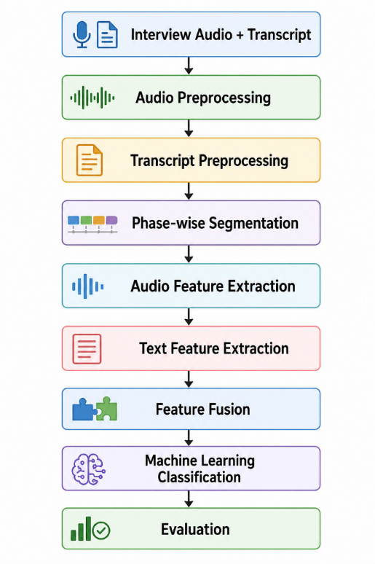

Fig. 5. Multimodal architecture: parallel acoustic and linguistic feature extraction pathways with feature-level fusion for classification.
Table 3. Summary of features extracted from audio and text modalities.
Modality | Category | Features Extracted
Audio | Temporal / Energy | Speech duration, silence duration, speech-to-silence ratio, silence ratio, speaking rate, pause mean/std/max/total, avg. segment duration
Audio | Prosodic | Pitch mean/std/min/max/range/median/skew, voiced ratio, jitter, shimmer, HNR mean/std
Audio | Spectral | Spectral centroid, bandwidth, rolloff, contrast, flatness (mean, std, var each)
Audio | Cepstral (MFCCs) | 13 MFCCs × {mean, std, var} + 13 delta-MFCCs × {mean, std, var} = 78 features
Audio | Source/Energy | RMS mean/std, energy min/max/range/median/var, harmonic energy, percussive energy, onset count, articulation speed, word count
Text | Linguistic | Word count, sentence count, avg. sentence length, first-person ratio, negation count, uncertainty count, type-token ratio
Text | Temporal (Pauses) | Mean pause duration, max pause duration derived from transcript timestamps
Text | Semantic (SBERT) | 384-dim sentence embedding mean + 384-dim std = 768 SBERT features per participant-phase
Text | Sentiment (VADER) | Positive, negative, neutral, compound sentiment scores (used in initial extraction)

3.3.5 Classification Models.
Six machine learning classifiers are employed for binary depression classification. CatBoost is a gradient boosting algorithm with native categorical feature handling and built-in regularisation, well-suited to tabular data with mixed feature types . Random Forest is an ensemble of decision trees that captures non-linear feature interactions and provides feature importance estimates . XGBoost employs regularised gradient boosting with column subsampling, offering strong performance on high-dimensional tabular data . Support Vector Machine with a radial basis function kernel maps features to high-dimensional spaces to find optimal class boundaries . Logistic Regression provides a linear probabilistic baseline model. A Feedforward Neural Network with two hidden layers and ReLU activations captures complex non-linear patterns in the fused feature space.

4. Experimentation and Model Evaluation

4.1 Experimental Setup
All experiments are conducted on a workstation equipped with an Intel Core i7 12650H processor and 16 GB RAM running Windows 11. The software environment comprises Python 3.12, librosa 0.10, Parselmouth 0.4, scikit-learn 1.4, XGBoost 2.0, CatBoost 1.2, sentence-transformers 2.7, and PyTorch 2.1. Audio feature extraction was performed locally using the cleaned_audio directory of participant-isolated WAV files, while transcript processing was conducted on Google Colab.
Three evaluation configurations are applied: (i) a single train-test split (80:20), (ii) 5-fold stratified cross-validation, and (iii) 10-fold stratified cross-validation. Stratification preserves the class distribution across folds. Standard metrics are computed for each configuration:
Accuracy = (TP + TN) / (TP + TN + FP + FN)
Precision = TP / (TP + FP); Recall = TP / (TP + FN)
F1-Score = 2 × (Precision × Recall) / (Precision + Recall)
StandardScaler applied to all feature matrices prior to classification. For the Feedforward Neural Network, two hidden layers of dimensions 256 and 128 with ReLU activation and dropout (p = 0.3) are trained using the Adam optimiser for 100 epochs with a learning rate of 0.001.

4.2 Results and Outputs
4.2.1 Dataset Distribution.
The DAIC-WOZ dataset has a class imbalance across the 423 participant-phase samples: 297 samples (70.2%) are labelled non-depressed and 126 samples (29.8%) are labelled depressed. Each of the three phases contains 141 samples with identical class proportions, confirming consistent stratification. Figure 6 illustrates the dataset class distribution.
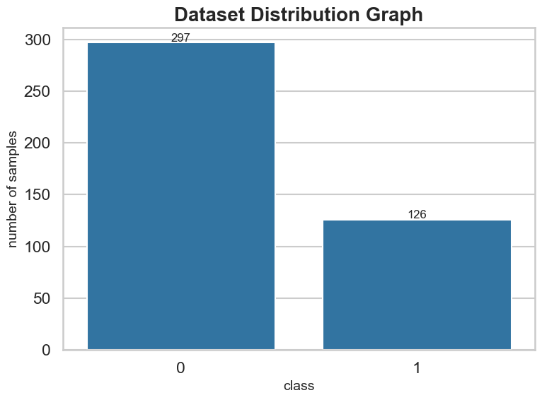
Fig. 6. Class distribution of the DAIC-WOZ dataset across phases: non-depressed (0) versus depressed (1) sample counts per phase.
4.2.2 Model Performance Comparison.
Table 4 presents the performance of all six classifiers under 10-fold cross-validation for Phase 1 across text-only, audio-only, and multimodal feature configurations. The multimodal configuration consistently achieves the highest accuracy and balanced F1-scores across all models. Random Forest got the best overall performance with 83.6% accuracy and F1-score of 0.71, followed by XGBoost (82.3%, F1: 0.67) and SVM (82.5%, F1: 0.65). In the text-only configuration, CatBoost has the best performance with 83.9% accuracy, but it had a lower recall for the depressed class. Audio-only models perform considerably worse, confirming that acoustic features alone are not sufficient for reliable depression classification in this dataset.
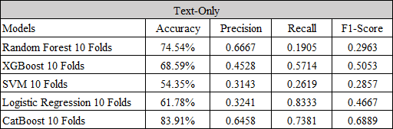
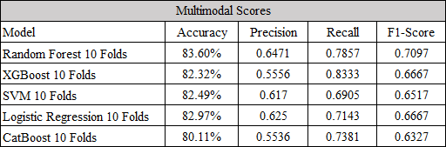
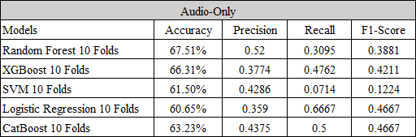
Table 4. Model performance under 10-fold cross-validation, Phase 1.

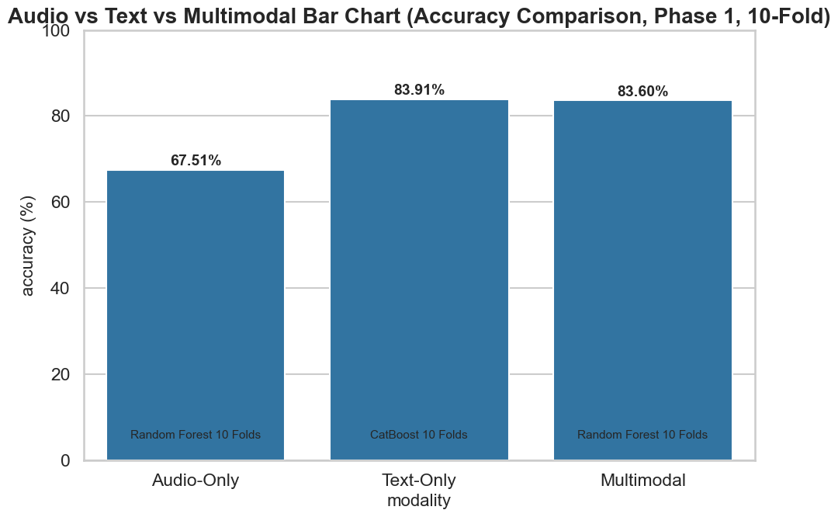
Fig. 7. Comparative accuracy of audio-only, text-only, and multimodal configurations across classifiers for Phase 1 under 10-fold cross-validation.
4.2.3 Phase-wise Analysis.
Table 5 presents the multimodal performance of all classifiers across the three conversational phases under 10-fold cross-validation. A consistent pattern emerges: Phase 1 yields the highest accuracy and F1-scores across all models, indicating that early interview responses carry the strongest discriminative depression signals. Performance degrades progressively through Phase 2 and Phase 3, with Phase 3 showing the largest drop. Random Forest achieves 83.6%, 79.3%, and 77.9% accuracy in Phases 1, 2, and 3 respectively, a trend mirrored across all classifiers.

Table 5. Phase-wise model performance under multimodal 10-fold cross-validation.
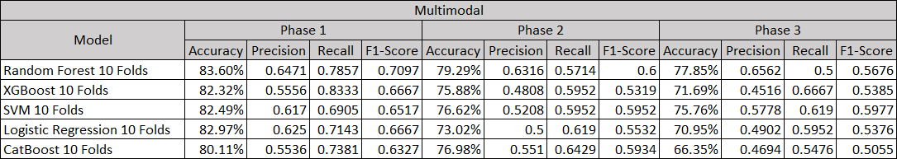

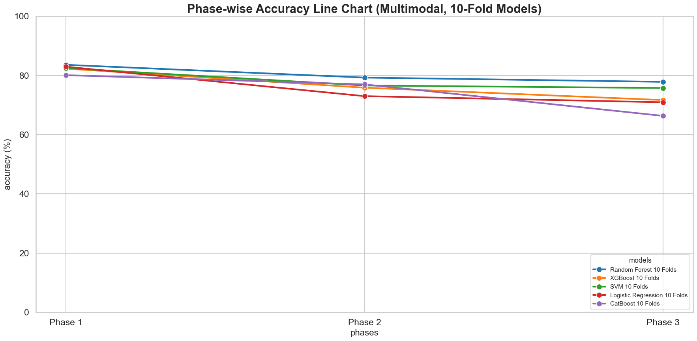
Fig. 8. Phase-wise accuracy trends for all classifiers under multimodal 10-fold cross-validation, illustrating progressive performance decline across conversational phases.

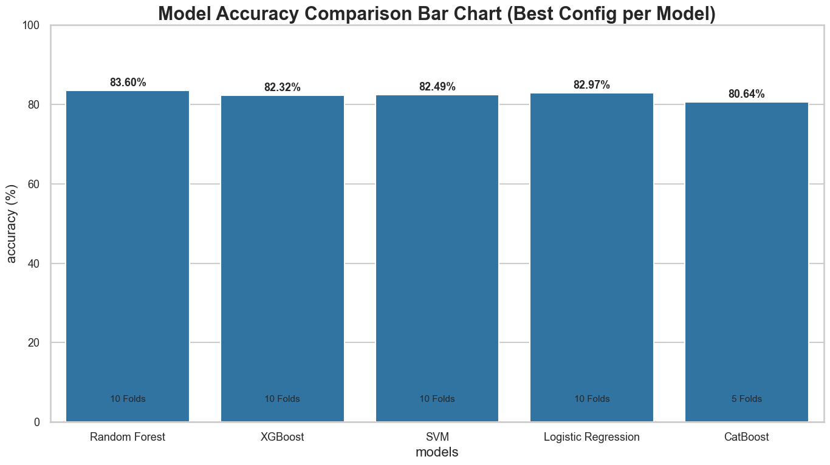
Fig. 9. Comparative model accuracy under the best-performing configuration (multimodal, 10-fold cross-validation, Phase1).
4.2.4 Feature Importance Analysis.
We did an analysis to see which features are important. We used the Random Forest classifier model on the features we got from Phase 1. The results show that some features from the SBERT embeddings are really important for classifying things. The features sbert_std_56, sbert_std_5 and sbert_mean_7 are the important ones. We also saw that some acoustic and speech features, like pause_std, pause_mean MFCC-1 mean and spectral_contrast_std are important too.The SBERT features that show the mean and standard deviation are really important. This shows that the way words are related to each other and the way they sound are both important.
The SBERT features and the acoustic features all work together to help us understand what is going on. The SBERT features like sbert_std_56 and sbert_mean_7 are still really important. Figure 10 presents the top 20 features by importance.
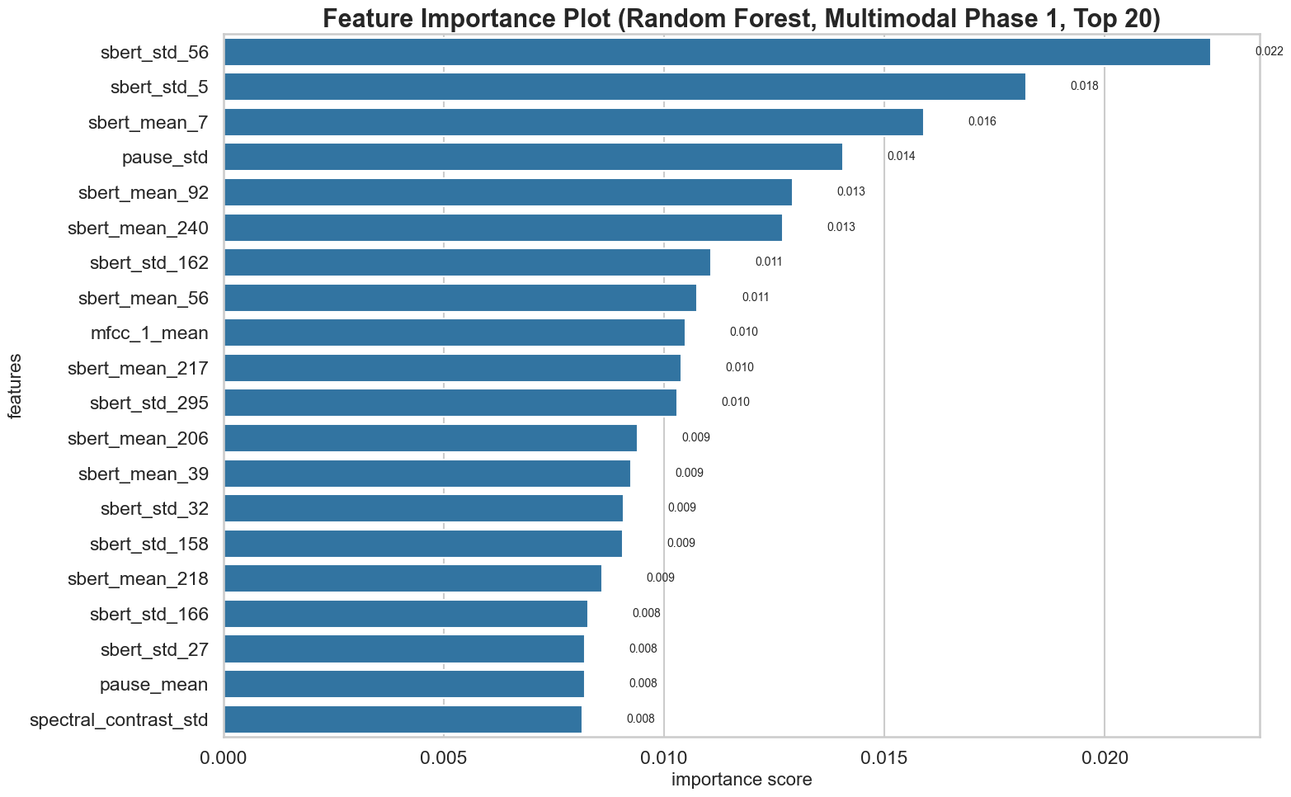
Fig. 10. Top 20 most important features from the multimodal Random Forest model (Phase 1, 10-fold cross-validation), spanning acoustic, prosodic, and semantic modalities.
4.2.5 Confusion Matrix.
Figure 11 shows us the confusion matrix for the multimodal Random Forest model. This is the model uses 10 fold cross-validation on the Phase 1 data. The confusion matrix tells us that the multimodal Random Forest model is the best among the other selected models at classifying things. It does not make mistakes when it says someone is not depressed when they really are. This is very important in screening because missing a depressed person is a bigger problem, than saying someone is depressed when they are not. The multimodal Random Forest model is doing a job with this.
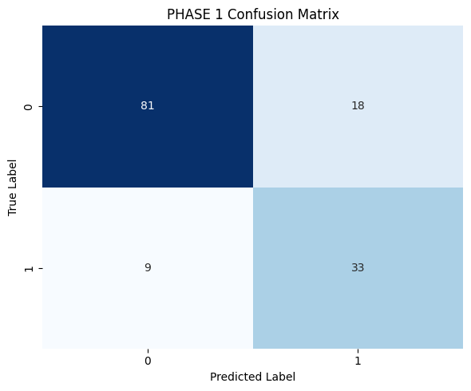
Fig. 11. Confusion matrix for the best-performing multimodal Random Forest classifier (Phase 1, 10-fold cross-validation).

5. Validation / System Performance Evaluation
The experimental results yield several analytically significant observations regarding the effectiveness of the proposed system. The consistent superiority of the multimodal configuration over both unimodal baselines confirms that acoustic and linguistic modalities provide complementary and largely non-redundant information about depressive states. While text-only models leveraging Sentence-BERT embeddings perform comparably to multimodal systems in terms of raw accuracy (CatBoost text-only: 83.9% vs. Random Forest multimodal: 83.6% in Phase 1), the multimodal configuration achieves more balanced precision-recall trade-offs, which is of greater clinical significance in screening applications.
The pronounced performance advantage of Phase 1 over subsequent phases is particularly noteworthy. Early interview segments, during which participants are responding to introductory and self-referential questions, appear to contain the richest depression indicators. This aligns with clinical observations that depressed individuals exhibit constrained vocabulary, heightened first-person singular pronoun use, and altered prosodic contours when discussing personal states. As the interview progresses toward more structured and topic-constrained dialogue in Phases 2 and 3, these distinctive behavioural patterns may become less pronounced or more variable, reducing classifier discriminability.
The strong performance of CatBoost on text-only features is attributable to its regularised gradient boosting mechanism, which effectively handles the high-dimensional (777-feature) SBERT-dominated feature space. Conversely, Random Forest’s superiority in the multimodal configuration suggests that ensemble decision-tree approaches are well-suited to the heterogeneous acoustic-linguistic feature space. The relatively weaker performance of the Feedforward Neural Network, despite achieving high recall for the depressed class, indicates high false-positive rates in this dataset size regime, confirming that deep learning approaches require larger datasets to generalise reliably.
The audio-only configuration’s substantially lower performance across all models and phases highlights the limitations of acoustic features when analysed in isolation. The high precision but low recall of audio-only Random Forest (e.g., 52.0% precision, 31.0% recall, Phase 1) indicates that while certain acoustic patterns are specific to depression, they are insufficient to capture the full spectrum of depressive behavioural markers without linguistic context.
The preprocessing pipeline’s contribution is evidenced by the feature quality: extracting participant-only audio using ground-truth timestamps eliminates cross-speaker contamination, directly improving the reliability of prosodic and energy-based features. Similarly, transcript cleaning ensures that semantic embeddings reflect genuine participant language use rather than artefactual annotation noise.

6. Discussions on Contributions
This study contributes to the field of computational mental health analysis through several methodologically distinct advances. First, the preprocessing-centric design philosophy—in which participant isolation, spectral filtering, and transcript cleaning are treated as primary determinants of downstream feature quality rather than afterthoughts—offers a replicable and rigorous data preparation framework applicable to other clinical interview datasets.
Second, the phase-wise conversational segmentation is a novel analytical dimension that moves beyond the prevailing whole-interview analysis paradigm. By demonstrating that Phase 1 features are systematically more discriminative than those from later phases, this work provides actionable insight for the design of shorter, targeted screening instruments that focus on early interview responses.
Third, the comprehensive feature engineering approach—combining 132 acoustic features including MFCCs with delta coefficients, voice quality measures (jitter, shimmer, HNR), and a full complement of spectral descriptors with 777 text features including Sentence-BERT semantic embeddings and linguistic markers—creates a rich, interpretable 909-dimensional multimodal representation that does not rely on black-box end-to-end deep learning architectures.
Fourth, the systematic comparative evaluation across six classifiers, three evaluation protocols, three conversational phases, and three modality configurations generates a comprehensive performance landscape that provides clear empirical guidance for model selection in clinical NLP applications. The identification of CatBoost as the strongest text-only model and Random Forest as the best multimodal model offers practically actionable recommendations.

7. Conclusion and Future Scope
This paper presented a preprocessing-focused multimodal framework for automated depression detection from clinical interview data. Operating on the DAIC-WOZ corpus, the system extracted 132 acoustic and 777 linguistic features per participant-phase record, evaluated six machine learning classifiers across three conversational phases and multiple cross-validation protocols. Key findings establish that: (i) the multimodal configuration consistently outperforms unimodal baselines, achieving 83.6% accuracy and 0.71 F1-score with Random Forest under 10-fold cross-validation; (ii) Phase 1 features provide the strongest depression discrimination, suggesting that early interview responses carry the richest behavioural indicators; and (iii) CatBoost and Random Forest are the most reliable classifiers for this task, with deep learning models requiring larger datasets to demonstrate their full potential.
Several limitations should be acknowledged. The DAIC-WOZ dataset, while widely used, contains 141 participants a sample size that may limit generalisation, particularly for deep learning models. The class imbalance (70:30) may bias classifiers toward the majority class. Pause features derived from transcript timestamps may not perfectly reflect true acoustic pause distributions. Future work will address these limitations through: (i) application of transformer-based language models (e.g., RoBERTa, BioMedBERT) for richer semantic feature extraction; (ii) exploration of attention-based multimodal fusion architectures; (iii) extension to larger and more demographically diverse corpora; (iv) integration of real-time audio processing for clinical screening applications; and (v) investigation of cross-corpus generalisation to assess robustness across different interview protocols and recording conditions.

References
[1] Y. Guo, C. Zhu, S. Hao, and R. Hong, “A topic-attentive transformer-based model for multimodal depression detection,” arXiv preprint arXiv:2206.13256, 2022.
[2] L. Gan, Y. Huang, X. Gao, J. Tan, F. Zhao, and T. Yang, “Multimodal magic: Elevating depression detection with a fusion of text and audio intelligence,” Preprint, 2025.
[3] Y. Gong and C. Poellabauer, “Topic modeling based multi-modal depression detection,” in Proc. 7th Annu. Workshop Audio/Visual Emotion Challenge (AVEC ’17), ACM Multimedia, 2017.
[4] M. Nykoniuk, O. Basystiuk, N. Shakhovska, and N. Melnykova, “Multimodal data fusion for depression detection approach,” Computation, vol. 13, no. 1, p. 9, 2025.
[5] H. Yoo and H. Oh, “Depression detection model using multimodal deep learning,” Preprints, 2023.
[6] Z. Xu, Y. Gao, F. Wang, L. Zhang, L. Zhang, J. Wang, and J. Shu, “Depression detection methods based on multimodal fusion of voice and text,” Scientific Reports, vol. 15, p. 21907, 2025.
[7] J. Park and N. Moon, “Design and implementation of attention depression detection model based on multimodal analysis,” Sustainability, vol. 14, no. 6, p. 3569, 2022.

